Submit A Reservation Request (External Users)
- Click The Link On The Main Menu To Submit A New Request.
If you don’t have a College Of The Canyons email address select the link “Submit An Event (External Users) on Screen R-1
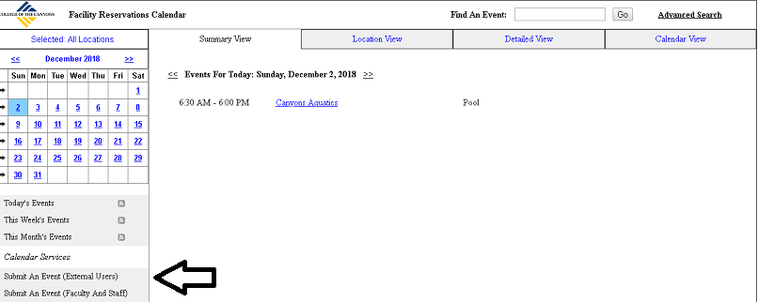
Screen R-1
This opens the screen below (Screen R-2)
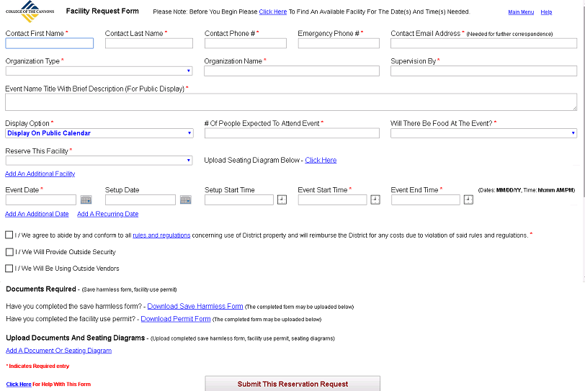
Screen R-2
- Enter All Required Fields
Fields on Screen R-2 with a red asterisk are required. More information on selected fields below:
Organization Type: Select the best option that describes the organization responsible for the event. Examples: (Non-Profit, Private, Public).
Supervision By: Enter the person or organization responsible for the event.
Event Name Title With Brief Description (Public Display): This is the description of the event that will appear on all public notices of the event including the event calendar.
Display Option: This determines the public visibility (Description of event, contact information) of your event.
Display On Public Calendar: No restrictions on visibility.
Require Campus Login To View: Only users with a campus login can see information about your event.
Do Not Display Anywhere: No users may see information about your event.

Will There Be Food At Event: Will food or drink be allowed at the event.
Reserve This Facility: Select the campus location to reserve.

- Selecting A Facility
Selecting a facility on Screen R-2 expands the screen depending on the facility chosen. Example: Selecting “East Gym” displays the options on Screen R-3
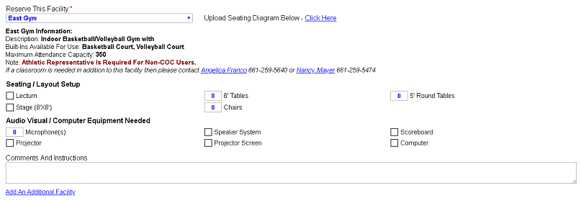
Screen R-3
Information about the selected facility will appear below the pick list and options for what can be reserved for the facility. A diagram for seating may be uploaded in the “Upload Documents And Seating Diagrams” section (See Bottom of Screen R-2). Additional comments and instructions about your intended use of the facility can be entered in the “Comments And Instructions” section on Screen R-3.
NOTE: More than one facility can be selected for the reservation. Click the link “Add An Additional Facility” to add additional facilities.

- Select Reservation Dates And Times
On Screen R-2 enter reservation date(s) and time(s) in the boxes under the “Reserve This Facility” selection box (See Screen R-4)
Screen R-4
Enter the Event Date in MM/DD/YY format. Only enter Setup Date if it is different from the Event Date. Setup Start Time is optional. Event Start Time and Event End Time format is h:mm AM/PM. Example: 2:00 PM.
Add additional dates by clicking the “Add An Additional Date” link. This will add additional lines for data entry. Multiple dates may be entered through a wizard using the “Add A Recurring Date” link.

- Remaining Entries
The remaining entries are shown in Screen R-5
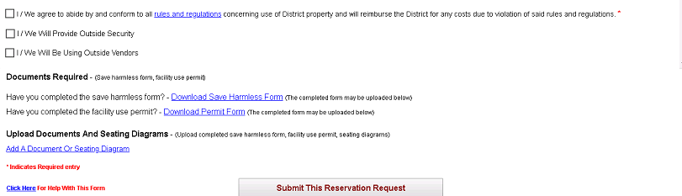
Screen R-5
The first checkbox in Screen R-5 must be checked. Check the other checkboxes only if outside security is needed or if outside vendors will be used. Checking either of these boxes expands the screen to display additional fields for entry (Screen R-6).
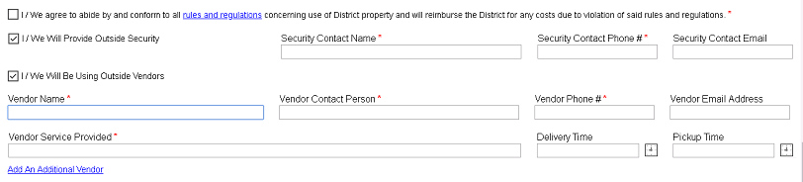
Screen R-6
Additional vendors can be entered by clicking the link “Add An Additional Vendor”. Delivery Time And Pickup Time are in h:mm AM/PM format (Example: 2:00 PM).

- Uploading Documents And Diagrams
Upload the Save Harmless Form, Facility Use Permit, Seating Diagrams, or and other documents by clicking the link “Add A Document Or Seating Document” on Screen R-2. This opens Screen R-7.
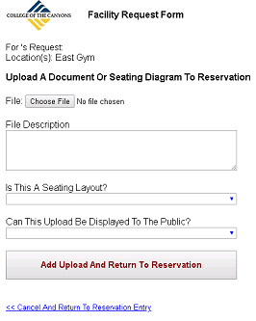
Screen R-7
To include a document from your PC click the “Choose File” button to open the dialog window in Screen R-8. This dialog window allows a user to browse their PC for a file to upload.
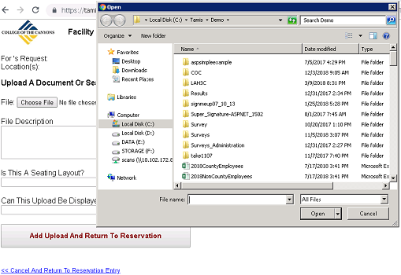
Screen R-8
Select a file to upload and complete the remaining fields on Screen R-7 to produce a result as in Screen R-9. Please indicate if the upload is a seating layout and if is acceptable to have the upload available for download from the public calendar.
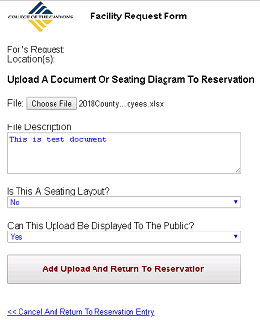
Screen R-9
- Submit Your Reservation Request
Press the “Submit This Reservation Request” button on Screen R-2 when all required fields are completed. If your reservation request either conflicts with an existing reservation or conflicts with a pending reservation (Unapproved, but submitted earlier) Screen R-10 will open.
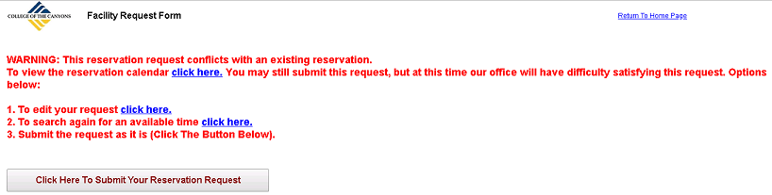
Screen R-10
A request may still be submitted if there are conflicts. Our office will try to resolve the conflict and find suitable accommodation for all events. To submit a request with conflicts press the “Click Here To Submit Your Reservation Request” button on Screen R-10. Screen R-11 will open.
If there are no conflicts the request will be submitted and Screen R-11 will open directly.
An email with a link to the request will be sent to the email address entered on the reservation request.
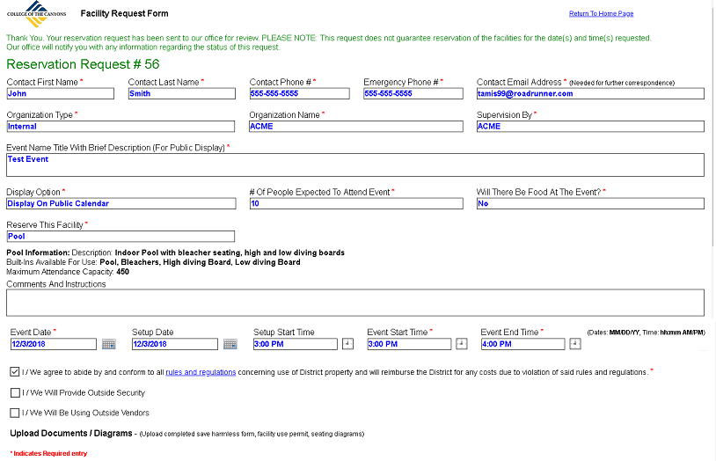
Screen R-11

